**Social site**

**Started with creating Virtualevn and git.**

**>>>git init**

**Creating .gitignore file, because virtualenv should not go in there.**

**How to add .gitignore info?**

| **Pattern** | **Example matches** | **Explanation\*** |
| --- | --- | --- |
| **/logs | logs/debug.log logs/monday/foo.bar build/logs/debug.log | You can prepend a pattern with a double asterisk to match directories anywhere in the repository. |
| **/logs/debug.log | logs/debug.log build/logs/debug.log *but not* logs/build/debug.log | You can also use a double asterisk to match files based on their name and the name of their parent directory. |
| *.log | debug.log foo.log .log logs/debug.log | An asterisk is a wildcard that matches zero or more characters. |
| *.log  !important.log | debug.log trace.log *but not* important.log logs/important.log | Prepending an exclamation mark to a pattern negates it. If a file matches a pattern, but *also* matches a negating pattern defined later in the file, it will not be ignored. |
| *.log  !important/*.log trace.* | debug.log important/trace.log but not important/debug.log | Patterns defined after a negating pattern will re-ignore any previously negated files. |
| /debug.log | debug.log but not logs/debug.log | Prepending a slash matches files only in the repository root. |
| debug.log | debug.log logs/debug.log | By default, patterns match files in any directory |
| debug?.log | debug0.log debugg.log but not debug10.log | A question mark matches exactly one character. |
| debug[0-9].log | debug0.log debug1.log but not debug10.log | Square brackets can also be used to match a single character from a specified range. |
| debug[01].log | debug0.log debug1.log but not  debug2.log debug01.log | Square brackets match a single character form the specified set. |
| debug[!01].log | debug2.log but not debug0.log debug1.log debug01.log | An exclamation mark can be used to match any character except one from the specified set. |
| debug[a-z].log | debuga.log debugb.log but not debug1.log | Ranges can be numeric or alphabetic. |
| logs | logs logs/debug.log logs/latest/foo.bar build/logs build/logs/debug.log | If you don't append a slash, the pattern will match both files and the contents of directories with that name. In the example matches on the left, both directories and files named logs are ignored |
| logs/ | logs/debug.log logs/latest/foo.bar build/logs/foo.bar build/logs/latest/debug.log | Appending a slash indicates the pattern is a directory. The entire contents of any directory in the repository matching that name – including all of its files and subdirectories – will be ignored |
| logs/  !logs/important.log | logs/debug.log logs/important.log | Wait a minute! Shouldn't logs/important.log be negated in the example on the left  Nope! Due to a performance-related quirk in Git, you can not negate a file that is ignored due to a pattern matching a directory |
| logs/**/debug.log | logs/debug.log logs/monday/debug.log logs/monday/pm/debug.log | A double asterisk matches zero or more directories. |
| logs/*day/debug.log | logs/monday/debug.log logs/tuesday/debug.log but not logs/latest/debug.log | Wildcards can be used in directory names as well. |
| logs/debug.log | logs/debug.log but not debug.log build/logs/debug.log | Patterns specifying a file in a particular directory are relative to the repository root. (You can prepend a slash if you like, but it doesn't do anything special.) |

If you want to ignore a file that is already checked in, you must untrack the file before you add a rule to ignore it. From your terminal, untrack the file.

$ git rm --cached *FILENAME*

[Configuring ignored files for all repositories on your computer](https://docs.github.com/en/github/using-git/ignoring-files#configuring-ignored-files-for-all-repositories-on-your-computer)

You can also create a global *.gitignore* file to define a list of rules for ignoring files in every Git repository on your computer. For example, you might create the file at *~/.gitignore_global* and add some rules to it.

1. Open Git Bash.
2. Configure Git to use the exclude file *~/.gitignore_global* for all Git repositories.

$ git config --global core.excludesfile ~/.gitignore_global

git init

git add README.md

git commit -m "first commit"

git branch -M master

git remote add origin git@github.com:SanctussBa/social-site.git

git push -u origin master

**How to make footer on the bottom of the site:**

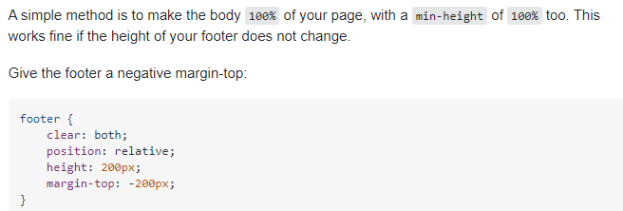

This only works if you know the height of your footer ahead of time. Sometimes footers have dynamic content, or your building a framework. Any ideas for variable height footers?

